**Unit 8 How are you?**

**第三课时 Sound time—Ticking time**

**基础巩固**

Review



**一、判断下列各组单词画线部分读音是(S)否(D)相同。**

( )1.dog fox ( )2.box sock

( )3.to come ( )4.not cold

( )5.coffee hot ( )6.doctor hello

**二、用所给词的适当形式填空。**

1. —May I ________to Tom? —This is Tom ________.(speak)

2. —How many toy ________(fox) can you see? —Only one.

3. Can I have ________(some) tea?

4. You can't eat ________(some) ice creams. You ________(be) ill.

5. Here ________(be) some water for you.

**三、根据所给中文提示填空。**

1. Sam can’t ________ ________(来) the party today.

2. Do you play football ________ ________(放学后)?

3. —What's the matter with your brother?

—He ________ ________ ________ ________(患重感冒).

4. The ________ ________ ________ ________(盒子里的三明治) are very nice.

5. ________ ________(保重), Helen.

**能力提升**

Unit



**四、单项选择。**

( )1.This girl is fine now. She________go skating today.

A.can’t B.can C.is

( )2.I’m very tired. Can I________now, Mum?

A.sit on the chair B.do my homework C.play basketball

( )3.The balloon is________the tree. The pears are________the tree.

A.in; in B.in; on C.on; in

( )4.—What’s the matter with________?

—She________a cold.

A.she; has B.her; have C.her; has

( )5.We don’t have any lessons________Sundays.

A.in B.on C.at

**五、看图，完成对话，每空一词。**

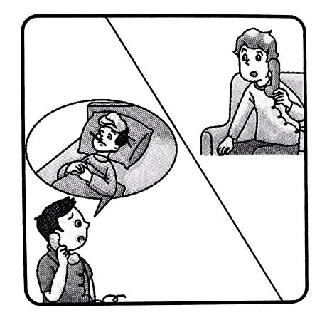**A:** Hello, ________ is Mike speaking.

**B:** Hello, Mike. This ________Wang Bing.

**A:** Hi, Wang Bing. ________your brother at school?

**B:** No. He’s ________ home.

**A:** ________is he today?

**B:** Not so ________.

**A:** What's the matter with ________?

**B:** He ________a cough and a ________.

**A:** I'm ________to hear that. Can I come to see ________after school?

**B:** OK. Thank ________.

**拓展训练** Goal



**六、任务型阅读。**

From 8:00 a. m.—11:30 a. m. , 1st November.

|  |  |  |  |
| --- | --- | --- | --- |
| **Class** | **Name** | **Symptoms(症状) Advice** | **He shouldn't eat too many sweets.** |
| 1 | Mike | He has a toothache. | He should drink a lot of warm water. |
| 6 | Jack | He has a cold and a fever. | He should take some medicine. |
| 5 | Sam | He has a terrible headache. | She should drink some water and take some medicine. |
| 3 | Lucy | She has a fever. | She should drink more water. |
| 2 | Betty | She has a bad cold. | She can't eat too much. |
| 6 | Lily | She has a stomach ache(胃痛). | He shouldn't eat too many sweets. |

根据光明小学校医 11月 1日上午记录学生疾病情况的表格，完成下列句子，每空一词。

1. Mike shouldn't eat too many sweets because he has a ________.

2. Jack and Lily are in the same ________. Jack has a ________and a fever.Drinking a lot of warm ________is good for him. Lily has a stomach ache. She ________eat too much food.

3. ________ha s a terrible headache. He should take some ________.

4. Lucy is from Class ________. She has a ________today.

5. Betty has a bad ________. She should drink more ________.

参考答案

第三课时 Sound time—Ticking time

一、1-6SSDDSD

二、1. speak, speaking

2. foxes 解析· how many 后接可数名词复数, fox的复数形式是 foxes。

3. some 解析·“Can I have ... ?”是征求他人意见并希望得到肯定答复的疑问句，表示“一些”时用 some。

4. any, are 解析· You can't eat ... 是否定句,表示“一些”用 any。you 是第二人称, be动词用are。

5. is

三、1. come to 2. after school 3. has a bad cold 4. sandwiches in the box 5. Take care

四、1-5BABCB

五、this, is, Is, at, How, good, him, has,fever, sorry, him, you

六、1. toothache 解析·根据 Mike的就医记录可知，他不应该吃太多 糖果，因为 他牙疼。

2. class, cold, water, can't 解析根据Jack和 Lily的就医记录可知，他们都是六班的学生。Jack 感冒发烧了，应该喝大量的温水； Lily 胃痛，不能吃太多食物。

3. Sam, medicine 解析·根据 Sam 的就医记录可知，应该吃一些药。

4. 3/Three, fever 解析·根据 Lucy 的就医记录可知，她是三班的学生，今天发烧了。

5. cold, water 解析·根据 Betty 的就医记录可知，她得了重感冒，应该多喝水。