**Unit 8 How are you?**

**第一课时Story time**

**基础巩固**

Review

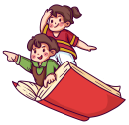

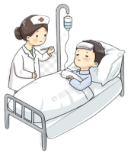**一、根据首字母或图片提示，补全句子或对话。**

1.—What’s the matter________ ________?

—I am________.

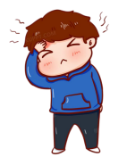

2.—Is Jack fine?

—No. He________ a________.

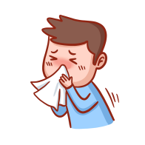

3.He________go to school. He________ a________.

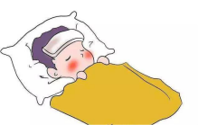

4.—My brother________ a________.



—Drink m________ w________ w________.

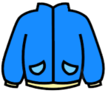5.—Helen is________.

—Here’s a________ for________.

**二、单项选择。**

( )1. Is Mike here? I want to speak to ________.

A. he B. him C. her

( )2. I ________a cold and my sister ________ a cough.

A. have; has B. have; have C. has; has

( )3. —How are you? —________.

A. I'm nine B. I'm fine, thank you C. See you tomorrow

( )4. It's ________ today. I have ________.

A. cold; cold B. cold; a cold C. a cold; cold

**能力提升**

Unit



**三、从II栏中选出与I栏相对应的答句，将其序号写在题前的括号内。**

I II

( )1.May I speak to Miss Li? A.Not so good.

( )2.How are you? B.I have a bad headache.

( )3.How is your friend? C.Hello! This is Miss Li.

( )4.What’s the matter? D.I’m sorry to hear that. Take care.

( )5.I have a cough. E.She’s fine.

**四、根据中文提示完成句子或对话。**

1. 明天晚上你能来我的派对吗?

Can you ________ ________ ________ ________tomorrow evening?

2. 迈克不在学校。

Mike ________ ________ ________.

3. —你还好吗? —不,我不好。

—Are you ________ ________? —No, I'm not.

4.—你是布莱克先生吗? —是的，我是布莱克先生。

—Is ________Mr Black speaking? —Yes, ________ is Mr Black.

**拓展训练** Goal



**五、任务型阅读。**

John is 12 years old. He has a bad cold. He goes to see the doctor. The doctor gives him some medicine.

|  |
| --- |
| **How to use this medicine**  Take it three times a day.  Age≥14(years old) 2 teaspoons(一茶匙) every time  8-13(years old) 1 teaspoon every time  4-7(years old) 1/2 teaspoon every time  Not right for children(≤3 years old).  Put it in a cold place.  Use it before 1st December, 2024. |

(一) 阅读材料，选择正确的答案。

( )1. What's the matter with John?

A. He has a fever. B. He has a cough. C. He has a bad cold.

( )2. John goes to see the ________.

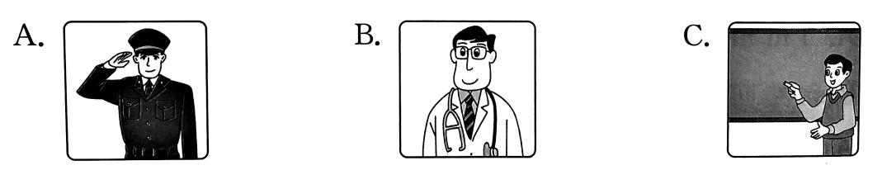

(二) 阅读材料，完成下列句子，每空一词。

1. John should take the medicine ________ times a day.

2. John should put the medicine in a ________place.

(三) 阅读材料，回答下面的问题。

John's sister is two years old. She has a cold too. Can she take this medicine?

________________________________________________________________

参考答案

第一课时 Story time

一、1.with him; ill 2.has; headache 3.don’t; has; cough 4.has; fever; much warm water

5.cold; jacket; her

二、1. B 解析·speak to sb意为“和某人说话”。to 是介词，后接人称代词宾格形式，且Mike 是男性,用 him指代。故选B。

2. A 3. B

4. B 解析· cold 用作形容词时,意为“冷的”; cold 用作名词时,意为“感冒”,have a cold 是 固定搭配,意为“患 感冒”。故选 B。

三、1-5CAEBD

四、1. come to my party 2. isn't at school3. all right 4. that, this

五、(一) 1. C 解析·根据“He has a bad cold.”可知, John 得了重感冒。故选C。2. B 解析·根据“He goes to see the doctor.”可知, John去看医生。故选 B。

(二) 1. three 解析·根据“Take it three times a day.”可知, John 应该一天吃三次药。

2. cold 解析· 根 据“Put it in a cold place.”可知, John 应该把药品放在冷的地方。

(三) No, she can't. 解析· 根据“Not right for children(≤3 years old).”可知,3 岁以下的儿童不能吃这个药，所以 John 两岁的妹妹不能吃这个药。