**Unit 7 What's the matter?**

**第三课时 Sound time—Ticking time**

**基础巩固**

Review



**一、判断下列各组单词画线部分读音是(S)否(D)相同。**

( )1.close go ( )2.music fish

( )3.open hot ( )4.match cake

( )5.time it ( )6.cold home

**二、用所给词的适当形式填空。**

1. Here ________(be) some bread for you.

2.—________(be) they hungry? —No, they ________.

3. —I ________(can) skate. —Don't be sad. I can help you.

4. Can we have ________(some) apple pies?

5. This is Mrs Mouse ________(speak).

6. Bill is ill. Please take ________(this) pills.

**三、根据所给中文提示填空。**

1. Look at ________ ________ ________(那个伤心的女孩).

2.—Can I ________ ________ ________(喝些水)? —Sure.

3. Tina is thirsty. She would like ________ ________ ________ ________ ________(一杯橙汁).

4. I want ________ ________ ________ ________(睡觉). I'm tired.

5. Please ________ ________ ________ ________(给我看你的鼻子).

**能力提升**

Unit



**四、单项选择。**

( )1.Here some noodles for you.

A.is B.are C.am

( )2.—I’m . —Here’s a chair for you.

A.hungry B.thirsty C.tired

( )3.Nancy a flower. Her friends some flowers too.

A.have; have B.has; has C.has; have

( )4.— your sister tired? —Yes, .

A.Is; I am B.Are; she is C.Is; she is

( )5.—What’s wrong, Ivan?

—I’m very . I’d like .

A.hungry; some juice B.hot; a fan C.thirsty; a hamburger

**五、Liu Tao正在跟妈妈分享他的朋友圈，从方框中选择合适的句子补全对话。**

|  |
| --- |
| A. She is thirsty. B. What's the matter?  C. Are you hungry now, Taotao? D. She feels very hot.  E. Look, Helen wants to drink some milk. |

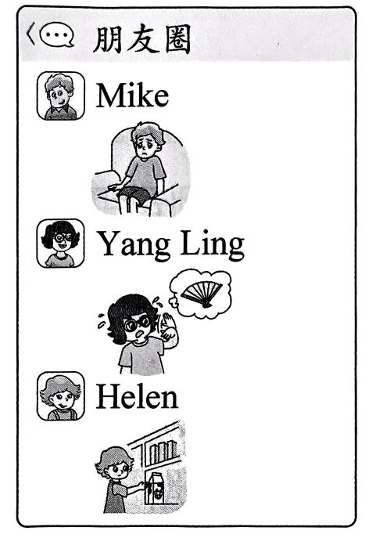**Liu Tao:** Mum, Mike doesn't feel well today.

**Mum:** 1. ________

**Liu Tao:** He's tired. He should go to bed early.

**Mum:** Yes. What about Yang Ling?

**Liu Tao:** 2. ________Sh e would like a fan.

**Mum:** OK. 3. ________

**Liu Tao:** 4. ________

**Mum:** 5. ________

**Liu Tao:** Yes. I want to have dinner.

**Mum:** OK. Dinner is ready. Let's go to the living room.

**拓展训练** Goal



**六、阅读对话，完成下列句子，每空一词。**

**Mike:** I'm hungry. Let's go to a snack bar.

**Children:** Great!

**Waiter:** Can I help you?

**Mike:** Yes. I'd like a hamburger. What about you, Helen?

**Helen:** I'm not hungry, but I'm thirsty.

**Waiter:** What about a glass of water?

**Helen:** No, thank you. I'd like some orange juice.

**Mike:** How about you, David?

**David:** I'm not hungry. And I'm not thirsty either.

**Mike:** What's the matter? Are you ill?

**David:** No, but I'm tired. I want to go home now.

**Mike:** OK. Goodbye, David.

**David:** Goodbye.

1. The children are at ________ ________ ________.

2. Mike is ________. And he would like a ________.

3. Helen is ________. She wants ________ ________ ________.

4. David is ________. He wants to ________ ________.

参考答案

第三课时 Sound time—Ticking time

一、1-6SSDDDS

二、1. is 2. Are, aren't

3. can't 解析·根据答句“Don't be sad. I can help you.”可知,“我”不会溜冰。

4. some 5. speaking

6. these 解析· pills 意为“药片”,是复数形式,用 these 来修饰。

三、1. that/the sad girl 2. have/drink some water 3. a glass of orange juice 4. to go to bed 5. show me your nose

四、1-5BCCCB

五、1. B 2. D 3. E 4. A 5. C

六、1. a snack bar 解析·根据“Let’s go to a snack bar.”可知,孩子们在一个小吃店。

2. hungry, hamburger 解析·根据“I’m hungry. ”和“I’d like a hamburger.”可知， Mike 饿了，他想要一个汉堡包。

3. thirsty, some orange juice 解析·根据“but I'm thirsty”和“I'd like some orange juice.”可知, Helen 渴了, 她想要一些橙汁。

4. tired, go home 解析·根据“No, but I'm tired. I want to go home now.”可知, David累了,他想回家。