**Unit 7 What's the matter?**

**第二课时 Fun time—Cartoon time**

**基础巩固**

Review



**一、英汉互译。**

1.吃两个苹果馅饼 2.喝一些水

3.去睡觉 4.晚安。

5.你还好吗？ 6.给你。

7.sit still 8.take this pill

9.Here's a fan. 10.Show Rose your nose.

**二、用 be 动词的适当形式填空。**

1. —What's the matter, Susan? —I ________ tired.

2. —________you happy? —Yes, I ________.

3. Here ________some rice. And here ________two cakes.

4. —I ________sad. I can’t fly. —Don’t ________ sad. I can’t fly either.

5.—Can I have some water? I ________thirsty. —Here you ________.

**三、单项选择。**

( )1. I want ________home.

A. to go to B. to go C. go

( )2. —What's the matter? You don't look so good.

—I’m so ________. Maybe(也许) I’m ill.

A. hungry B. happy C. cold

( )3.—What's the matter with ________? —He's hungry.

A. you B. her C. him

( )4. Hello, Mrs Brown. This is Miss Li ________.

A. speak B. speaking C. speaks

( )5. —It's ten o’clock. Time ________bed. —________, Mum.

A. to; Goodbye B. to; Good night C. for; Good night

**能力提升**

Unit



**四、从方框中选择合适的内容，补全对话。**

A.It’s six o’clock.

B.He plays football with his friends in the playground.

C.my son David doesn’t come back

D.Where is he?

E.What time is it?

**A:** 1.________

**B:** 2.________

**A:** It’s time to have dinner. But 3.________

**B:** Oh, my dear! 4.________

**A:** 5.________

**四、按要求完成句子。**

1. I'm thirsty. (对画线部分提问)

________ ________ matter with you?

2. Have a cake, please. (改为否定句)

________ ________a cake, please.

3. Wang Bing wants to go to bed. (改为同义句)

Wang Bing ________ ________to go to bed.

4. I’m ill.(改为一般疑问句，并作肯定和否定回答)

—________ ________ ill?

—Yes,________ ________.(肯定回答)

—No,________ ________.(否定回答)

**五、看图，并根据所给首字母提示完成对话。**

(Lingling and Fangfang are in the p________. They see an old woman sitting on the ground.)

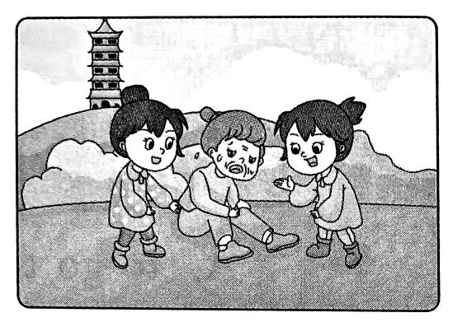**Lingling:** Fangfang, who’s s________?

**Fangfang:** Let's go and have a l________.

**Lingling & Fangfang:** What's the m________?

**Madam(女士):** My leg h________. I c________walk.

**Lingling & Fangfang:** Let us h________ you.

**Madam:** You're so n________. Thank you.

**拓展训练** Goal



**六、阅读短文，回答下列问题。**

Today is Sunday. Yang Ling, Helen and Mary play in the park. Oh, it's eleven o’clock. It's time to have lunch. They would like to eat something. Now they are at a snack bar near the park. Yang Ling is very hungry, so she would like a hamburger. Helen is hungry too. But she doesn't like hamburgers. She would like a cake. Mary is not hungry, but she's thirsty. So she would like a cup of tea. At last, they pay(付钱) twenty-five yuan for the food and drink.

1. Is Yang Ling in the park now?

2. What time is it?

3. What would Yang Ling like?

4. What's the matter with Mary?

5. How much are the hamburger, the cake and the tea?

参考答案

第二课时 Fun time—Cartoon time

一、1. have/eat two apple pies 2. have/drink some water 3. go to bed 4. Good night.

5. Are you all right? 6. Here you are.

二、1. am 2. Are, am 3. is, are 4. am,be 5. am, are

三、1. B 解析· want to do sth 意为“想要做某事”; home 是副词,与动词 go 连用时，中间不加介词 to。故选 B。

2. _, “我”生病了，只有 cold 符合语境。故选 C。

3. C 解析· with 是介词,后接人称代词的宾格形式。根据答句中的“He’s”可知用 him。故选 C。

4. B 解析·“This is ... speaking.”是电话用语,意为“我是……”。故选 B。

5. C

四、1. What's the 2. Don't have 3. would like 4. Are you, I am, I'm not

五、park, she, look, matter, hurts, can't,help, nice

六、1. No, she isn't. 解析·根据“Now they are at a snack bar near the park.”可知, Yang Ling 现在在公园附近的一家小吃店里。

2. It's eleven o'clock. 解析·根据“Oh, it's eleven o'clock.”可知,十一点了。

3. She would like a hamburger. 解析根据“Yang Ling is very hungry, so shewould like a hamburger.”可知, Yang Ling想要一个汉堡包。

4. She is thirsty. 解析 ·根据“Mary is not hungry, but she's thirsty.”可知, Mary 口渴了。

5. They're twenty-five yuan. 解析·根据“At last, they pay twenty-five yuan forthe food and drink.”可知,汉堡包、蛋糕和茶一共是25 元。