**Unit 7 What's the matter?**

**第一课时Story time**

**基础巩固**

Review



**一、根据图片或首字母提示填空。**



1.—He’s t________. —Here is some ________ for him.

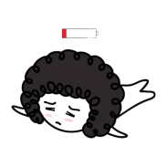

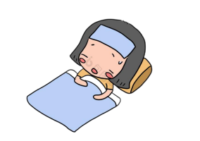2. —What’s the m________, Mary? —I’m very ________.

3. —Are you ________ , Lili?



—No, I'm ________ .

4. I am very h________ now. I want to have a sandwich.

**二、选词填空。**

1. Can I have ________(some/any) noodles?

2. I want ________(to go/go) to bed.

3. Here ________(is/are) some milk for you.

4. —________(Who’s/What’s) the matter? —I’m ________(thirty/thirsty).

5.—Here ________(you are/are you). —Thank you.

**三、单项选择。**

( )1.—________you play table tennis? —Yes, I can.

A. Is B. Are C. Can

( )2.—What's the matter with the dog? —________.

A. It's hungry B. I'm happy C. It can run

( )3.—Here ________some hot dogs for you. —Thank you.

A. is B. are C. aren't

( )4. —You don't look well. ________you ill? —Yes, I ________.

A. Can; can B. Are; am C. Do; don't

**能力提升**

Unit



**四、看图，完成对话，每空一词。**

**Linda & Peter:** Hello, Amy.

**Amy:** Hi, Linda. Hi, Peter. Welcome to my home. Have some ________, Linda.

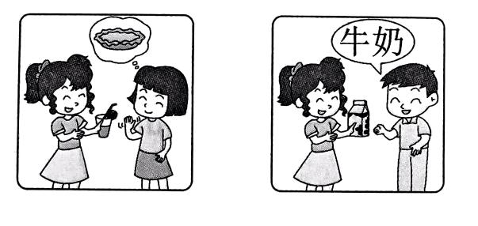**Linda:** I'm not ________, but I'm ________. Can I

have a ________?

**Amy:** Sure. Here you are. What about you, Peter?

**Peter:** I'd like some ________, please.

**Amy:** OK. Here you are.

**五、将下列句子重新排列成一段完整的对话。**

A.Oh, hurry up. It’s time for lunch.

B.What time is it, Helen?

C.I see. Here’s some water for you.

D.But I’m not hungry.

E.What’s the matter?

F.I’m tired and thirsty.

G.It’s eleven fifty.

H.Thank you.

|  |  |  |  |  |  |  |  |
| --- | --- | --- | --- | --- | --- | --- | --- |
|  |  |  |  |  |  |  |  |

**拓展训练** Goal



**六、阅读短文,判断正(T)误(F)。**

Are you feeling sad, tired, forgetful(健忘的), or unhappy today? It may be the weather's problem. Different weather can influence(影响) people's feelings. Winter may be a bad time for thin people. They usually feel cold during these months. They feel unhappy. But fat people may have a hard time in hot summer. At about 18℃, people feel comfortable. Low air pressure(低气压) can make people forgetful. People leave more bags on buses and in shops on these days.

( )1. If you feel sad, it is the weather's problem.

( )2. Thin people usually feel unhappy in cold winter.

( )3. Fat people may like hot summer.

( )4. People feel comfortable at a temperature of about 18℃.

( )5. Pressure can make people forget their bags on buses.

参考答案

第一课时 Story time

一、1. thirsty, water 2. matter, tired 3. ill, sad 4. hungry

二、1. some 2. to go 3. is 4. What's,thirsty 5. you are

三、1. C 解析·根据答句“Yes, I can.”可知,问句要用 can 来提问。故选 C。

2. A 解析·询问“狗怎么了”，要用句型“It’s …”回答。故选 A。

3. B 4. B

四、juice, thirsty, hungry, pie, milk

五、BGADEFCH

六、1. F 解析·根据“Are you feeling sad,tired, forgetful, or unhappy today? It may be the weather's problem.”可知, 如果你感到伤心，有可能是天气的问题。故填F。

2. T 解析·根据“Winter may be a bad time for thin people. They usually feel cold during these months. They feel unhappy.”可知，瘦弱的人在寒冬通常感到不开心。故填 T。

3. F 解析·根据“But fat people may have a hard time in hot summer.”可知,胖的人在炎热的夏天比较难熬，而不是喜欢夏天。故填 F。

4. T 解析·根据“At about 18℃, people feel comfortable.”可知,人们在大约 18 摄氏度感觉舒服。故填 T。

5. F 解析· 根据“Low air pressure can make people forgetful. People leave more bags on buses and in shops on these days.”可知，是低气压可以让人们把包忘在公共汽车上，而不是压力。故填F。