**Unit 6 Whose dress is this?**

**第三课时 Sound time—Ticking time**

**基础巩固**

Review

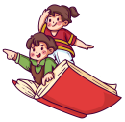

**一、判断下列单词画线部分的读音是否相同，相同的写“S”，不相同的写“D”。**

( )1.fish music ( )2.like kite

( )3.six rice ( )4.pig ride

( )5.cat cake ( )6.pity bike

**二、用所给词的适当形式填空。**

1. Her eyes ________(hurt).

2. —Whose shorts ________(be) they? —Sorry, I don't know.

3. This robot can ________(move) and ________(jump).

4. It's my ________(grandma) sweater.

5. These trousers are beautiful. Try ________(they) on, please.

6. —________(who) ________(be) they? —They're Helen and Mike.

**三、根据所给中文提示填空。**

1.—His ________(新外套) is black. —Yes, it's cool.

2.—Let’s ________ ________ ________ ________(去参加聚会). —Great!

3. I________ ________ ________ ________(听一些英语) every morning.

4. Let’s have picnics ________ ________ ________(在湖边).

5. The brown shoes are ________ ________(太小).

**能力提升**

Unit



**四、将下列句子重新排列为一段通顺的对话。**

( ) Yes. I'm very sad.

( ) You look sad today.

( ) What's the matter?

( ) Oh! I'm sorry to hear that.

( ) My hands hurt.

**五、看图，并根据所给首字母提示完成对话。**

**Peter:** Hello, Lucy. W________ to the Fancy Dress Party! Look at my g________.

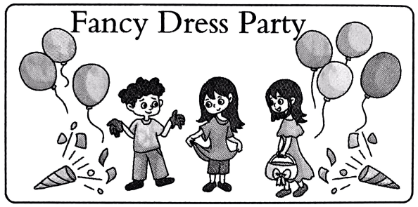**Lucy:** Wow, t________so big!

**Peter:** Your T-shirt is too l________. You look so f________.

**Lucy:** Yes, it's my father's. Look at the girl o________ there.

**Peter:** W________ is she?

**Lucy:** Oh, she's my sister Lily.

**Peter:** She looks b________.

**Lucy:** Yes. Her d________ is my m________.

**Peter:** Really? That's cool.

**拓展训练** Goal



**六、按要求完成句子。**

1学科网(www.zxxk.com)--教育资源门户，提供试卷、教案、课件、论文、素材及各类教学资源下载，还有大量而丰富的教学相关资讯！.This is Liu Tao’s coat.(改为否定句)

________ ________Liu Tao’s________.

2.They are my mother’s skirts.(改为一般疑问句)

________they ________mother’s________?

3.They are Miss Li’s jeans.(对画线部分提问)

________jeans________ ________?

4.There are three pairs of shorts.(改为单数句)

There________ a________ of________.

**七、完形填空。**

Welcome to my classroom. Let's 1 a game now. It's about finding lost(丢失的) things. 2 T-shirt is this? It is 3 . It has a picture of a monkey on it.Tom 4 it very much. And 5 wants to go to the zoo to see monkeys this Sunday. Whose pencil case is this? It is Lily’s. There is a 6 of a doll on it. Whose crayons are 7 ? They are Jack’s. Why? Because Jack has 8 art lesson after school today. And he is looking for his crayons now. Is your guess right?

( )1. A. watch B. play C. help

( )2. A. Who B. Who’s C. Whose

( )3. A. Tom's B. Tim's C. Lily's

( )4. A. has B. sees C. likes

( )5. A. it B. he C. she

( )6. A. box B. picture C. bag

( )7. A. this B. these C. that

( )8. A. a B. an C. two

参考答案

第三课时 Sound time—Ticking time

一、1-6SSDDDD

二、1. hurt 解析·主语eyes 是可数名词复数,后面的谓语动词用原形。

2. are 3. move, jump

4. grandma’s 解析· sweater 是名词,前面要用名词所有格，表示“某人的……”。

5. them

6. Who, are 解析· 根 据 答句“ They’re Helen and Mike.”可知,问句是对人物提问,要用疑问词 who;且主语 they 是复数, be动词用 are。

三、1. new coat 2. go to the party 3. listen to some English 4. by the lake 5. too small

四、2 1 3 5 4

五、Welcome, gloves, they're, long, funny,over, Who, beautiful, dress, mother's

六、1.This isn’t; coat 2.Are; your; skirts 3.Whose; are they 4.is; pair; shorts

七、1. B 解析· play a game 意为“玩游戏”,是固定搭配。故选 B。

2. C 解析·由下文“It is _.”并结合此空的选项可知，这一句询问的是“这件 T恤衫是谁的?”，用疑问词 whose 进行提问。故选 C。

3. A 4. C

5. B 解析· Tom 是个男生,要用 he 指代。故选 B。

6. B

7. B 解析·设空处前面的 are 是复数形式,所以填 these。故选 B。

8. B 解析· art 的发音以元音音素开头, 所以用不定冠词an。故选 B。