**Unit 6 Whose dress is this?**

**第二课时 Fun time—Cartoon time**

**基础巩固**

Review

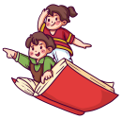

**一、根据首字母提示填空。**

1. The t________ are on the chair. But they are too l________ for you.

2. Her mother knitted(编织) her a white s________.

3.—W________dress is this? —It's h________ dress.

4. It's too hot. You can take off your c________.

**二、用所给词的适当形式填空。**

1. Look at ________(Tina) ________(mother) dress. It's so beautiful.

2. Look at these ________(shoe). You can try ________(they).

3.—What's the matter? —My hand ________(hurt).

4. The toy panda is for ________(he).

5. Whose ________(short) are they?

**三、单项选择。**

( )1.—Whose jacket is this?

—It’s________.

A.my father B.David’s sister C.Yang Ling’s cousin’s

( )2.—Whose________are they?

—They’re his.

A.coat B.jacket C.sweaters

( )3.—What would you like?

—I’d like________.

A.a gloves B.a pair of short C.a pair of socks

( )4.Look at________dolls. They________so beautiful.

A.this; are B.these; is C.those; are

( )5.—My coat is too big.

—________, please.

A.Try it B.Try this C.Try

**能力提升**

Unit



**四、按要求完成句子。**

1. This is my mother's coat.(对画线部分提问)

________ ________is this?

2. These are scarfs.(改为单数句)

________ ________a________.

3. I think so. (改为否定句)

I ________ ________so.

4. The girl in red is my sister. (对画线部分提问)

________ ________ ________ in red.

**五、看图，完成对话，每空一词。**

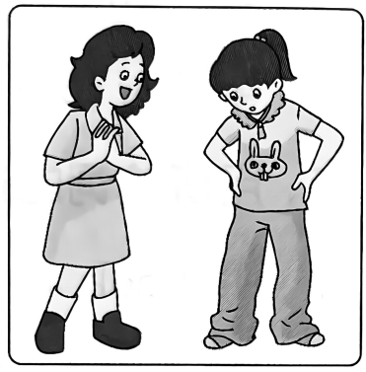**A:** ________these your ________?

**B:** No, they ________.

**A:** Look at them. They're ________ ________.

**B:** Yes. ________my sister’s. I can’t find my trousers.

**A:** Are your trousers in your wardrobe(衣柜)?

**B:** Yes, ________ ________. Thank you.

**A:** Not at all.

**拓展训练** Goal



**六、阅读对话，完成下列句子，每空一词。**

**Liu Tao:** Where are you going, Mike?

**Mike:** I'm going to a party. Look at my brown coat. It's my brother's.

**Liu Tao:** Oh, it's smart.

**Mike:** Thank you. How about my gloves?

**Liu Tao:** They're nice. But they're so big. They're blue. I like the colour.

**Mike:** Whose gloves are these? Guess!

**Liu Tao:** They're your brother's.

**Mike:** No. You're wrong. They're my father's.

**Liu Tao:** Can I go to the party with you?

**Mike:** Sure. Let's go.

1. Mike is going to a ________.

2. The brown coat is Mike’s ________.

3. The big gloves are ________. Liu Tao likes the colour.

4. These gloves are Mike’s ________.

参考答案

第二课时 Fun time—Cartoon time

一、1. trousers, long 2. sweater 3. Whose, her 4. coat

二、1. Tina’s, mother’s 2. shoes, them

3. hurts 解析· hand 是可数名词单数,后面的谓语动词要用第三人称单数形式。

4. him 解析·for是介词,其后接人称代词宾格形式, he的宾格是 him。

5. shorts

三、1-5CCCCB

四、1. Whose coat 2. This is, scarf 3. don't think 4. Who's the girl

五、Are, trousers, aren't, too long, They're,they are

六、1. party 解析· 根据“I’m going to a party.”可知, Mike 正打 算去 一 个派对。

2. brother’s 解析· 根据“Look at my brown coat. It's my brother's.”可知, 外套是 Mike 弟弟的。

3. blue 解析·根据“They’re blue. I like the colour.”可知,手套是蓝色的, Liu Tao 喜欢蓝色。

4. father's 解析· 根 据“ They’re my father's.”可知,手套是 Mike 爸爸的。