**Unit 6 Whose dress is this?**

**第一课时Story time**

**基础巩固**

Review

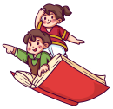

**一、根据图片提示，补全句子或对话。**

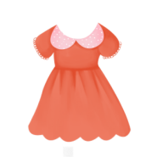1.—Look at my ________.

—________ so nice.

2.—________ ________(谁的毛衣)are these?

—They’re my mother’s.

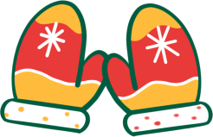

3.—Can I help you?

—Yes. I’d like________ ________ ________ ________.

4.It’s time________ ________ ________ ________(去参加聚会).

二、从方框中选择合适的单词填空。(每个单词限用一次)

|  |
| --- |
| What, Who's, Whose, When, Where |

1.—________T-shirt s are these? —They're my brother's.

2. —________is this? —It's a blue jacket.

3.—________that woman over there? —She's my mother.

4. —________are my shoes, Mum? —Look! They're under your bed.

5.—________do you go to school every day? —At seven thirty.

三、单项选择。

( )1. Look ________ my dress, please.

A. in B. on C. at

( )2. Your dress is too long. Try ________, Yang Ling.

A. these B. this C. those

( )3. —Whose gloves are these? —________.

A. It's Mike's B. They're Mike C. They're Mike's

( )4. —This pair of gloves ________ my mother’s. —How nice!

A. is B. are C. am

( )5. —________ are the socks? —Seven yuan.

A. How many B. How much C. How

**能力提升**

Unit



**四、根据中文提示完成句子或对话。**

1. —看我的新裙子。 —它这么漂亮！

—Look at my ________ ________. —It’s ________ beautiful!

2. 这些短裤太短了。

These ________ ________too ________.

3. —你的裤子是什么颜色的? —它们是棕色的。

—________ ________are your trousers? —They're ________.

4.—它们是谁的牛仔裤? —它们是他朋友的。

—________ ________ are they? —They’re________ ________.

5. 我想要两双黑色的鞋子。

I ________ ________two pairs of ________ ________.

**五、从II栏中选出与I栏相对应的答句，将其序号写在题前的括号内。**

I II

( )1.What’s that over there? A.Thank you.

( )2.Whose bag is it? B.Me too.

( )3.Look at my new dress. C.A new dress.

( )4.I like this new sweater. D.How pretty!

( )5.How nice! E.It’s Su Hai’s.

**拓展训练** Goal



六、阅读海报,判断正(T)误(F)。

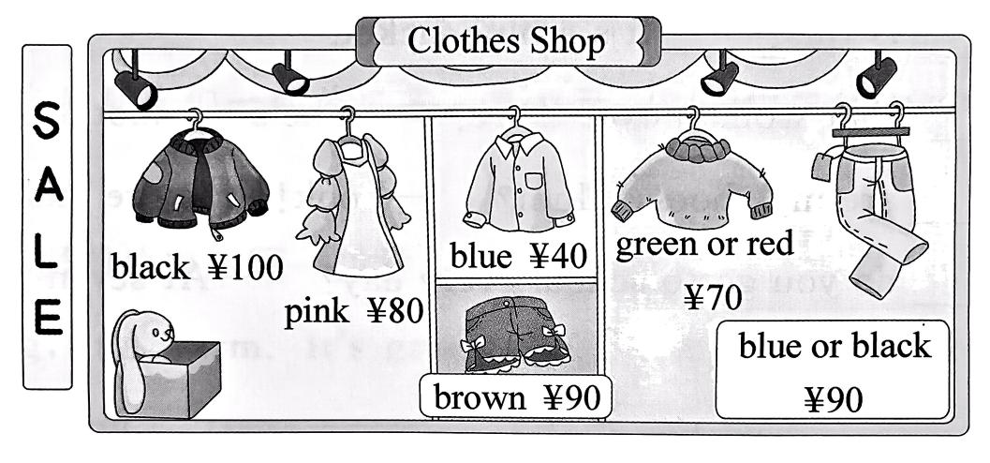

( )1. We can buy socks in this shop.

( )2. Liu Tao has 80 yuan. He can buy two shirts.

( )3. A pair of black jeans is ninety yuan.

( )4. The sweater is green and red.

( )5. I want a red dress and a pair of blue shorts. I can buy them in this shop.

参考答案

第一课时 Story time

一、1.dress; It’s 2.Whose sweater 3.a pair of gloves 4.to go to the party

二、1. Whose 2. What 3. Who’s 4. Where 5. When

三、1. C

2. B 解析·设空处是指代单数名词dress, 因此要用指示代词this。故选 B。

3. C 解析· gloves 是复数形式,代词要用they；名词后加 ’s 表示所属关系。故选C。

4. A 解析:“This pair of gloves”意为“这副手套”,中心词是 pair, pair 是可数名词单数，作主语时 be 动词用 is。故选 A。

5. B

四、1. new skirt, so 2. shorts are, short

3. What colour, brown 4. Whose jeans, his friend's 5. would like, black shoes

五、1-5CEDBA

六、1. F 解析·根据海报信息可知，这家商店不卖袜子。故填 F。

2. T 解析·根据海报信息可知，一件衬衫40 元, Liu Tao 用 80 元能 买 2 件。故填 T。

3. T 解析·根据海报信息可知，蓝色或黑色的牛仔裤每条90元。故填T。

4. F 解析·根据海报信息可知，毛衣是绿色或者红色的，而不是红绿相间的。故填 F。

5. F 解析·根据海报信息可知，商店里只有粉色的连衣裙和棕色的短裤，而没有红色的连衣裙和蓝色的短裤。故填F。