**Unit 5 Seasons**

**第二课时 Fun time—Cartoon time**

**基础巩固**

Review



**一、根据所给中文提示填空。**

1. —Let’s ________ ________(去滑冰) this morning. —OK.

2. We usually ________ ________(放风筝) on Sunday.

3. It’s ________ ________ ________(阳光明媚的一天) today.

4. My family and I all ________ ________(喜欢秋天).

5. Mary often ________ ________(野餐) with her friends.

**二、单项选择。**

( )1. I like ________. I can swim and eat ice creams.

A. summer B. winter C. spring

( )2. We go ________in the park every week.

A. boat B. boats C. boating

( )3. You can see a lot of flowers and green trees ________spring.

A. on B. at C. in

( )4. —________pencil is this? —It's my pencil.

A. Who's B. Whose C. Who

( )5. Here's a new book ________you.

A. to B. in C. for

**能力提升**

Unit



**三、从II栏中选出与I栏相对应的答句，将其序号写在题前的括号内。**

I II

( )1.When do you play basketball? A.Yes, I can.

( )2.Do you like spring? B.Wow! How beautiful!

( )3.What subjects do you like? C.I play it on Sunday.

( )4.Look at my new dress. D.No, I don’t.

( )5.Can you draw a park, Sam? E.I like Science and Music.

**四、按要求完成句子。**

1. I like spring.(改为否定句)

I ________ ________spring.

2. We can fly kites in spring.(对画线部分提问)

________ ________ ________ ________in spring?

3. This is my bag.(改为一般疑问句)

________ ________ ________bag?

4. We like spring. (对画线部分提问)

Which ________ do ________like?

5. It's time for picnics. (改为同义句)

It's time ________ ________picnics.

**五、根据所给首字母提示完成短文。**

There are four s________ in Nanjing. It is w________ in spring. We can go to the park and have p________. We can see many f________ and trees on the h________. We can go b________ on the r________. In s________, it is hot. We can eat ice creams and go s________. It's cool in a________. We can go c________. Winter is c________. I don’t like it.

**拓展训练** Goal



**六、阅读短文，选择正确的答案。**

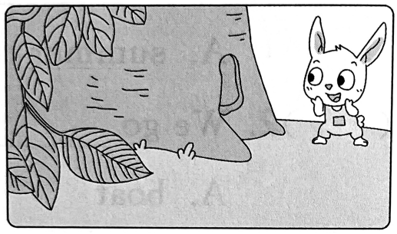Hello! I am a little rabbit. Look at the hole in the tree. It's my home. In spring, I like to pick flowers. They are beautiful. I like to play with the butterflies too. In summer, I sing songs with the birds. In fall, the leaves are usually yellow or red. I like to climb the hills. In winter, I like to make snowmen. It's great fun!

( )1. The little rabbit's home is ________.

A. on the leaves B. under the tree C. in the tree

( )2. What does the little rabbit like to do in spring?

A. Pick flowers. B. Play with the butterflies. C. Both A and B.

( )3. In summer, the little rabbit ________.

A. swims in the river B. climbs the hills C. sings songs

( )4. The underlined word“fall”means“________”.

A. spring B. autumn C. winter

( )5. What's the best title?

A. The seasons in a year B. A lovely little rabbit C. The little rabbit's life in four seasons

参考答案

第二课时 Fun time—Cartoon time

一、1. go skating 2. fly kites 3. a sunny day 4. like autumn 5. has picnics

二、1. A 解析·根据后一句“我可以游泳和吃冰淇淋”可知，“我”喜欢的是夏天。故选 A。

2. C 3. C

4. B 解析·根据答句可知，问句询问的是“这是谁的铅笔”，疑问词用 whose。故选 B。

5. C

三、1-5CDEBA

四、1. don’t like 2. What can you do 3. Is this your 4. season, you 5. to have

五、seasons, warm, picnics, flowers, hill,boating, river, summer, swimming, autumn, climbing, cold

六、1. C 解析·根据“Look at the hole in the tree. It's my home.”可知,小兔子的家在树里。故选C。

2. C 解析·根据“In spring, I like to pick flowers … I like to play with the butterflies too.”可知,小兔子在春天喜欢摘花和蝴蝶一起玩。故选 C。

3. C 解析· 根据“In summer, I sing songs with the birds.”可知,小兔子在夏天和小鸟一起唱歌。故选 C。

4. B

5. C 解析·通读全文可知，本文讲述的是小兔子一年四季的生活。故选C。