**Unit 4 Drawing in the park**

**第二课时 Fun time—Cartoon time**

**基础巩固**

Review



**一、用所给单词的适当形式填空。**

1.Helen (have) an English lesson on Monday.

2.How many (library) are there in your country?

3.Can you see these (tree)?

4.I like (cake).

5.He can (play) football.

**二、单项选择。**

( )1. —Can your sister skate? —Yes, ________.

A. she can't B. I can C. she can

( )2. Maths is ________for me, but I'd like to try.

A. easy B. difficult C. cool

( )3. —________in the box? —A CD.

A. Who's B. Where's C. What's

( )4. I can't see ________ hills over there.

A. some B. a C. any

**三、从方框中选择合适的短语填空。(每个短语限用一次)**

|  |
| --- |
| in the river, easy for me, on the lake, great fun, Try again, in the tree |

1. —Can you draw them? —Sure, it’s ________________.

2. I can see a parrot ________________.

3. —I can't play basketball. —________________. Believe yourself.

4. I would like to play football. It's ________________.

5. Can you see a duck ________________?

6. Can you see any fish ________________?

**能力提升**

Unit



**四、按要求完成句子。**

1. I can see a monkey in the tree.(对画线部分提问)

________ can you ________ in the tree?

2. We can make some cakes.(改为一般疑问句)

________ ________ make ________ cakes?

3. I can see some crayons in the box.(改为否定句)

I ________ see ________ crayons in the box.

4. This is a small box.(用these替换this改写句子)

________ ________ ________ ________.

**拓展训练** Goal



**五、阅读聊天记录，选择正确的答案。**

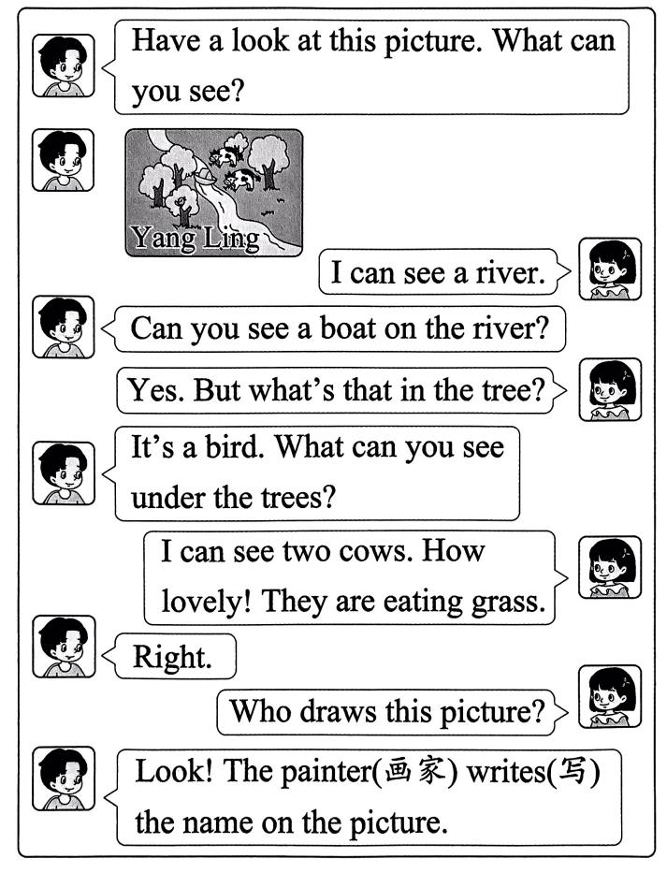

( )1. What can you see on the river?

A. A monkey. B. A boat. C. A bird.

( )2. How many trees are there in the picture?

A. Three. B. Four. C. Five.

( )3. Where is the bird?

A. In the tree. B. On the river. C. Under the tree.

( )4. The cows are ________in the picture.

A. sleeping B. eating C. running

( )5. ________draws this picture.

A. Amy B. Jim C. Yang Ling

参考答案

第二课时 Fun time—Cartoon time

一、1.has 2.libraries 3.trees 4.cakes 5.play

二、1. C 解析·问句中主语是 your sister,答句主语用代词 she, 根据“Yes”可知是肯定回答。故选C。

2. B

3. C 解析·根据答句“一张光盘”可知，问句询问的是盒子里有什么物品，用疑问词 what。故选 C。

4. C

三、1. easy for me 2. in the tree 3. Try again 4. great fun 5. on the lake 6. in the river

四、1. What, see 2. Can you, any 3. can't, any 4. These are small boxes

五、1. B 解析·根据“Can you see a boat on the river?”和“Yes.”可知,河面上有一只小船。故选 B。

2. C 解析·根据图片可知，有五棵树。故选 C。

3. A 解析·根据“But what s that in the tree?”和“It's a bird.”可知,鸟在树上。故选 A。

4. B 解析·根据“They are eating grass.”可知，奶牛正在吃草。故选 B。

5. C 解析·根据图画中的“Yang Ling”可知,是 Yang Ling 画的。故选 C。