**Unit 3 My day**

**第二课时 Fun time—Cartoon time**

**基础巩固**

Review



**一、从方框中选择合适的介词完成句子。**

|  |
| --- |
| in at on after |

1.I usually play basketball ________ class.

2.I get up ________ six thirty every day.

3.We have no lessons ________ Sundays.

4.We have three lessons ________ the morning.

**二、用所给词的适当形式填空。**

1. Can you see ________(some) cakes in the fridge?

2. It's eleven o'clock. It's time ________(have) lunch.

3. When do you do ________(you) homework every day?

4. Liu Tao usually ________(have) dinner at six thirty.

5. We have four ________(lesson) in the morning.

**三、根据所给中文提示填空。**

1. —What can you see ________ ________ (在那里)?

—I can see ________ ________ ________(一个大蛋糕).

2.—________ ________ (几点) is it now? —It's seven.

3. Liu Tao ________ ________(吃早饭) at six fifteen.

4. When do you ________ ________(回家) every day?

5. It’s time to ________ ________ ________(睡觉).

**四、从Ⅱ栏中选出与Ⅰ栏句子相对应的答句。**

I Ⅱ

( )1. What can you see on the tree? A. At seven.

( )2. What day is it today? B. I can see some apples.

( )3. Do they go to school at seven? C. It's seven.

( )4. What time is it? D. Yes, they do.

( )5. When do you do your homework? E. It's Thursday.

**能力提升**

Unit



**五、看图，并按照事情发展顺序，在横线上填写短语，帮助 Lily 完成短文。**

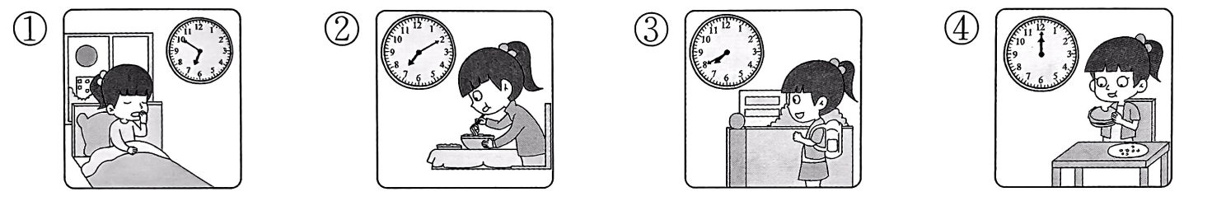

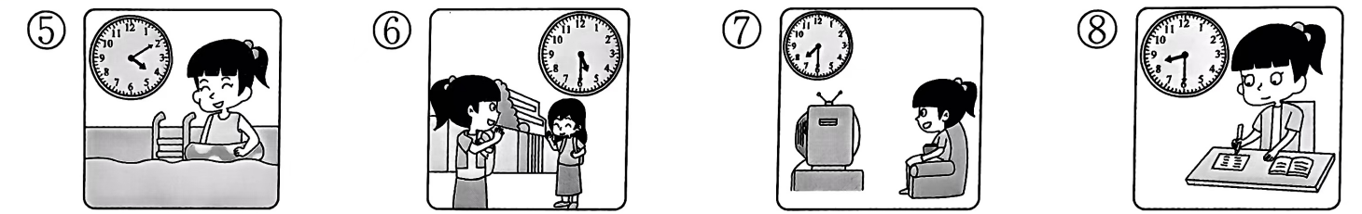

I 1. ________at six fifty. I usually have breakfast at home 2. ________. Ⅰ3. ________at seven forty. I have four lessons in the morning. I4. ________at twelve. In the afternoon, I have two lessons. After school, at four ten, I have a 5. ________. I 6. ________at five thirty. After dinner, at about seven thirty, I 7. ________. I usually 8.________at eight thirty.

**拓展训练** Goal



**六、阅读电视节目预告单，选择正确的答案。**

The list includes(包含) some TV shows on Channel 10(第十频道) of this Sunday. Please check and choose(选择) your favourite show right now!

|  |  |  |
| --- | --- | --- |
| 9:40 | Weather(天气) | A weather report for China |
| 10:00 | Art Show | Art from Australia(澳大利亚) |
| 12:00 | Happy Time | A film(电影): *Science teachers go to the park* |
| 14:00 | ABC English | Sing songs! Play games! Study English! |
| 14:30 | Music Time | Cool boys play cool music! |
| 15:00 | Cooking(烹饪) | Cook noodles with Jenny. |
| 16:20 | Sports | A football match |

( )1. We can watch the shows this ________.

A. Friday B. Saturday C. Sunday

( )2. Leo and Andy like music. They can watch TV at ________ in the afternoon.

A. two thirty B. two twenty C. one thirty

( )3. We can ________at four twenty in the afternoon.

A. watch a cartoon B. study English C. watch a football match

( )4. We can have a ________lesson with Jenny.

A. cooking B. swimming C. science

参考答案

第二课时 Fun time—Cartoon time

一、1.after 2.at 3.on 4.in

二、1. any 2. to have

3. your 解析· you 的形容词性物主代词是 your,用来修饰名词 homework。

4. has 解析·主语 Liu Tao 是第三人称单数，谓语动词要用 have 的第三人称单数形式 has。

5. lessons

三、1. over there, a big cake 2. What time3. has breakfast 4. go home 5. go to bed

四、1. B 2. E 3. D 4. C 5. A

五、1. get up 2. at seven ten 3. go to school 4. have lunch 5. swimming lesson 6. go home 7. watch TV

8. do my homework

六、1. C 解析·根据“The list includes some TV shows on Channel 10 of this Sunday.”可知,“我们”可以在这个星期日看到节目。故选C。

2. A 解析：根据 “14:30 Music Time Cool boys play cool music!”可知, Leo 和 Andy 可以在下午两点三十分看有关音乐的节目。故选 A。

3. C 解析·根据“16:20 Sports A football match”可知，“我们”可以在下午四点二十分看一场足球比赛。故选 C。

4. A 解析根据“15:00 Cooking Cook noodles with Jenny.”可知,“我们”可以和Jenny上一节烹饪课。故选 A。