**Unit 3 My day**

**第一课时Story time**

**基础巩固**

Review



**一、根据图片、首字母或中文提示填空。**

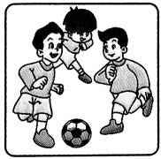

1. Let’s ________ ________ together.

2. —What time do you go h________?

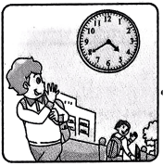

—At ________ ________ .

3. ________(什么时候) do you have ________(晚餐)?

4. I ________(通常) g________ up at seven.

5. I do my ________(家庭作业) before dinner every d________.

**二、从方框中选择合适的短语填空。(每个短语限用一次)**

|  |
| --- |
| What time, go to bed, at three, in the morning, have lunch |

1. I play with my doll at night. Then I ________________________.

2. We ________________ at twelve at school.

3. I have a swimming lesson ________________ in the afternoon.

4.—________________ is it now? —It's seven o’clock.

5. —When do you play basketball on Sunday?

—At nine ________________.

**三、单项选择。**

( )1. Tomorrow is Monday. Today is ________.

A. Tuesday B. Sunday C. Saturday

( )2. —Do you ________TV in the evening? —No, I don’t.

A. see B. watch C. look

( )3. —When do you go to school ________the morning?

—________six fifty.

A. at; On B. on; At C. in; At

( )4. It's nine o'clock. It's time ________bed.

A. to B. for C. go to

( )5. —________? —It's seven thirty.

A. What time is it B. What day is it today C. When do you have breakfast

**能力提升**

Unit



**四、根据中文提示完成句子。**

1. 星期六我们不上学。

We ________ go to school on ________.

2. 每个星期三海伦有一节英语课。

Helen ________ an ________ ________every ________.

3. 迈克早餐喝一些牛奶和吃一个鸡蛋。

Mike ________some ________and an ________for breakfast.

4. 双胞胎在四点四十分有一节游泳课。

The twins ________ a ________ ________at four ________.

**五、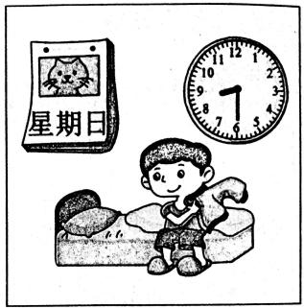看图，完成对话，每空一词。**

**A:** What is it today?

**B:** It's .

**A:** do you up?

**B:** thirty. about you?

**A:** Me .

**拓展训练** Goal



**六、阅读短文，根据短文内容，给下列图片排序。**

Today is Sunday. In the morning, I go to see some animals in the zoo with my father and mother. The pandas are very fat and the monkeys are so lovely. Then, we go to eat some food. The hamburgers and chips in the snack bar are so yummy. In the afternoon, we go to buy some new clothes in the shop. I look so cool in this T-shirt. Then, I play basketball with my friend. I can play it well. After dinner, I watch TV on the so fa with my father and mother. What a happy day!

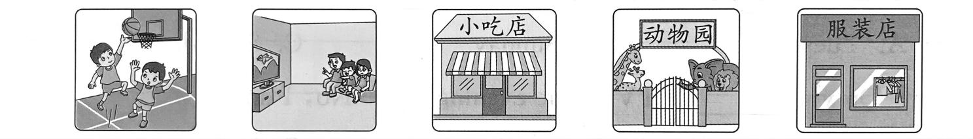

( ) ( ) ( ) ( ) ( )

**七、阅读Mike的假期时间表，判断正(T)误(F)。**

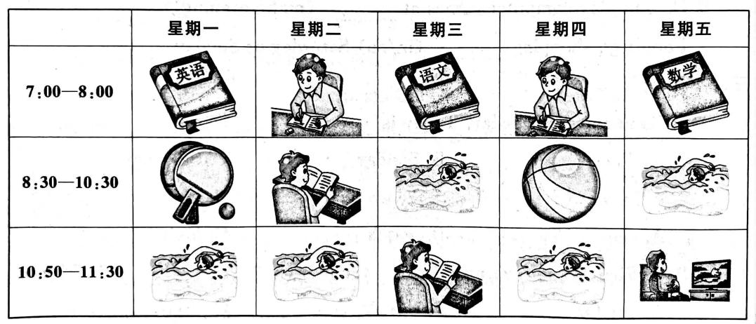

( )1.Mike studies English,Chinese and Maths every day.

( )2.Mike plays football on Thursday.

( )3.Mike likes swimming very much.

( )4.Mike plays table tennis on Monday afternoon.

( )5.Mike reads books on Tuesday and Wednesday.

参考答案

第一课时 Story time

一、1. play football 2. home, four forty 3. When, dinner 4. usually, get 5. homework, day

二、1. go to bed 2. have lunch 3. at three 4. What time 5. in the morning

三、1. B 2. B

3. C 解析·在年份、月份、春夏秋冬、早上、下午、晚上等时间段前用介词in；在某个确切的时刻用介词at。故选C。

4. B

5. A 解析·根据答句“七点半”可知，问句询问的是“几点了”，要用句型“What time is it?”。C 项询问的是“你什么时候吃早餐”，其答句要用句型“At+时间名词(短语).”。故选 A。

四、1. don’t, Saturday 2. has, English lesson, Wednesday 3. has, milk, egg 4. have, swimming lesson, forty

五、day,Sunday,What time,get,At eight, What,too

六、4 5 2 1 3

七、1.F 2.F 3.T 4.F 5.T