**Unit 1 Our school subjects**

**第一课时Story time**

**基础巩固**

Review



1. **根据图片、中文或首字母提示填空。**

1. Look! I have two ________ 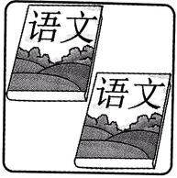books.

2. —Do you like ________ 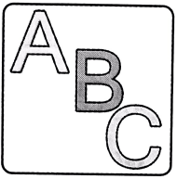? —Yes, I do.

3. Mr Li is a ________(数学) teacher.

4. —What s ________ do you like? —I like A________.

5. Su Yang and Su Hai can sing and dance. They like M________ very much.

1. **选词填空。**

1.—How many (lesson/lessons) do you have this morning?

—I have four. Oh!It's time (for/to)PE. Let's go.

2.Let's (has/have)a cake now.

3.—What (lessons/subjects) do you like? —Chinese and Art.

4.—This ruler is (on/for)you. —Thank you.

1. **用所给词的适当形式填空。**

1. —How many ________(subject) do you have this term?

—Six.

2. Look at ________(I) new clothes.

3. Let’s ________(go) to the playground.

4. It's time ________(play) football.

5. We don’t have ________(some) PE lessons in the morning.

1. **单项选择。**

( )1. Look at ________ timetable.

A.me B. our C. we

( )2. Mike and Liu Tao like ________. So they often play basketball after school.

A. Music B. Chinese C. PE

( )3. It's time ________ Music. Let's go to the music room.

A. to B. for C. of

( )4. —Welcome ________ our farm. —Thank you.

A. back B. at C. to

( )5. PE and Science ________ fun.

A. am B. is C. are

**能力提升**

Unit



1. **看图，完成对话，每空一词。**

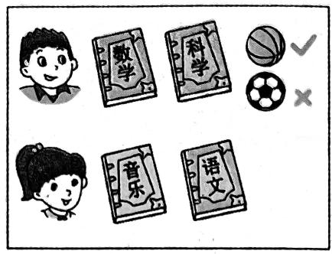**A:** What do you like,Liu Tao?

**B:** I like M and . What you,

Su Yang?

**A:** I like M and . Oh! It's time

PE. you like playing

**B:** No,but I like playing .

1. **根据中文提示完成句子或对话。**

1. 欢迎回到学校，同学们。

Welcome ________ to ________,________.

2. 看看我们的新课程表。我们有九门课程。

Look at ________ new ________. We have ________ ________.

3.—你呢? —我也喜欢科学。它是有趣的。

—________ ________ you? —I like ________too. It's ________.

4. 是上体育课的时候了。让我们去操场吧。

________time ________ PE.________go to the ________.

**拓展训练** Goal



1. **阅读对话,判断正(T)误(F)。**

**Linda:** How many lessons do you have today(今天)?

**Mike:** Three in the morning and three in the afternoon.

**Linda:** What lessons do you have in the morning?

**Mike:** I have Maths, English and Music.

**Linda:** When do you have an English lesson?

**Mike:** Let me see. I have an English lesson at nine twenty.

**Linda:** I have an English lesson at ten fifteen this morning.

( )1. Mike has three lessons today.

( )2. Mike has a Chinese lesson in the morning.

( )3. Linda has an English lesson today.

( )4. Mike has an English lesson at ten fifteen.

( )5. Mike and Linda are in the same(相同的) class.

1. **阅读表格，判断正(T)误(F)。**

This is Wang Bing, Helen, Su Hai and Bob's timetable for today.

|  |  |  |  |
| --- | --- | --- | --- |
|  | **Morning** | **Afternoon** | **Evening** |
| **Wang Bing** | English | Music | Art |
| **Helen** | Science | Chinese | Maths |
| **Su Hai** | Music | PE | Chinese |
| **Bob** | Maths | PE | English |

( )1.Wang Bing has Art this morning.

( )2.Su Hai and Helen have Chinese lessons today.

( )3.Wang Bing and Bob have Maths this evening.

( )4.Only one pupil(小学生)has Science today.

( )5.From this timetable,we can know what subjects they like.

参考答案

第一课时 Story time

一、1. Chinese 2. English 3. maths 4. subjects, Art 5. Music

二、1.lessons,for2.have3.subjects4.for

三、1. subjects

2. my 解析·clothes 是名词,要用形容词性物主代词 my来修饰。

3. go 解析· let sb do sth 意为“让某人做某事”, let 后接动词原形。

4. to play

5. any 解析·在否定句中表示“一些”要用 any。

四、1. B 解析· timetable是名词,意为“课程表”，要用形容词性物主代词 our 来修饰。故选 B。

2. C

3. B 解析·句型“It's time to do sth.”和“It's time for sth.”都可以用于表达“是该做某事的时候了”， to 后面接动词(短语)原形, for 后面接名词。Music 是名词,因此介词用for。故选 B。

4. C 5. C

五、subjects,Maths,Science,about,Music,Chinese,for,Do,football,basketball

六、1. back, school, class 2. our,timetable, nine subjects 3. What about, Science, fun

4. It's, for, Let's, playground

七、1. F 解析·根据“Three in the morning and three in the afternoon.”可知, Mike 今天有六节课，而不是三节课。故填 F。

2. F 解析·根据“I have Maths, English and Music.”可知, Mike 上午有数学、英语和音乐课，而没有语文课。故填 F。

3. T 解析·根据“I have an English lesson at ten fifteen this morning.”可 知, Linda今天有一节英语课。故填 T。

4. F 解析·根据“I have an English lesson at nine twenty.”可知, Mike 在九点二十分上英语课，而不是十点十五分。故填 F。

5. F 解析·通读整段对话可知, Mike 和Linda 上英语课的时间不同，由此可以推测出他们在不同的班级。故填 F。

八、1.F2.T3.F4.T5.F