教学内容 | Unit3 How many
备课人： | 冯向云 | 执教人 |  | 执教时间
教学目标 | 1.能听得懂、会说、会读和会拼写单词：thirteen, can, fifteen,sure， eighteen等；  2.能听懂、会说、会读和会写句型：Do you have…? How many … do you have? What do you have?等；  3.能正确理解课文内容，并在此基础上有感情地表演课文。  4.通过问题由简入深的设计，培养学生收集信息、获取信息的能力；  5.通过听说练习，提高学生的听力、口语表达能力及交流合作能力。  6.通过对文章的理解和感知，培养学生好东西与他人一起分享的良好情操；  7.通过体验、实践、讨论、合作、探究等方式，培养学生英语学习的兴趣和运用英语的意识。
教学重难点 | 1.能听得懂、会说、会读和会拼写单词：thirteen,can,fifteen,sure,eighteen等；  2.能掌握并在实际情境中灵活运用本课的重点句型；  3.能理解课文内容，有感情地表演课文。
教学准备 | 多媒体课件
教学环节 | 教师活动 |  | 学生活动 |  | 设计意图
Step1 Warm-up | - Enjoy a song:Number song  - T: What do you hear from the song? Can you count from one to nineteen? |  | - Enjoy and sing together.  - Discuss and count. |  | 歌曲导入能够有效调动课堂气氛，同时帮助有效复习旧有知识点，为本课的新授打下坚实的基础。
Step2 Presentation | - Let’s learn  Teach: thirteen  skirt  shirt  three  tree  The same way teach fourteen and fifteen.  - Let’s find  - --  - --  - --  - --  13---thirteen  14---fourteen  15---fifteen  T: Look at these words. Can you find some rules? Discuss in groups.  - Let’s play: Read out the numbers on the screen as quickly as possible. |  | - Ss read and learn the new words.  - Ss try to count from 16-19 and then find out the rules of numbers.  - Response and read.  Tip1：数字13到19都是以“teen”结尾，其中14 fourteen, 16 sixteen, 17 seventeen, 19 nineteen都是在原来各数“four, six, seven, nine”的基础上直接加“teen”，其他稍有变化。 |  | 采用语音拼读法帮助学生掌握单词的读音及其拼写，将事半功倍。  先让学生通过合作讨论的方式，找出构词规律，然后共同交流，最后老师做出总结，有利于鼓励学生积极思考，有利于提高学生自主学习及合作探究能力，同时也有利于学生更容易掌握单词的拼写。
Step3  Story time | - Look and say  T: Look at the picture. Who are they? What are those? What are these?(Teach: sticker)  - Watch and answer  Whose toy cars?  Whose stickers?  - Listen and fill  T: Now let’s listen to the tape and find out: How many toy cars does Mike have? And how many stickers does Helen have?  - Let’s ask  T: Who can be Mike and Helen and ask and answer like this?  A: How many ... do you have?  B: I have ...  - Read and find  T: Read the story by yourselves and find out: How do they give praise?  (1)How do they give praise?  A.They’re nice.  B.They’re very beautiful.  C.Great!  (2)Does Yang Ling like the stickers?  （杨玲喜欢贴纸吗）  从文中哪些句子可以看出杨玲喜欢贴纸?  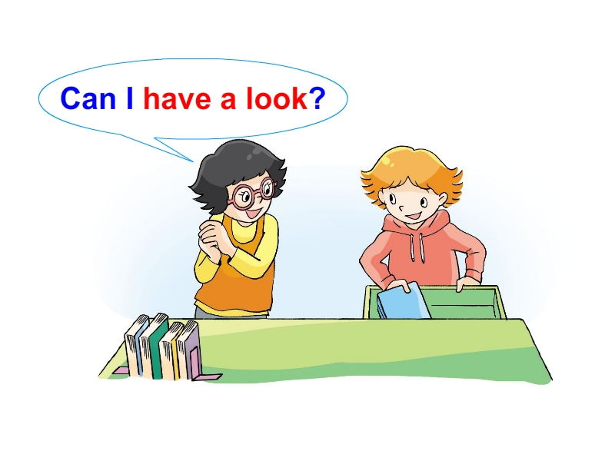  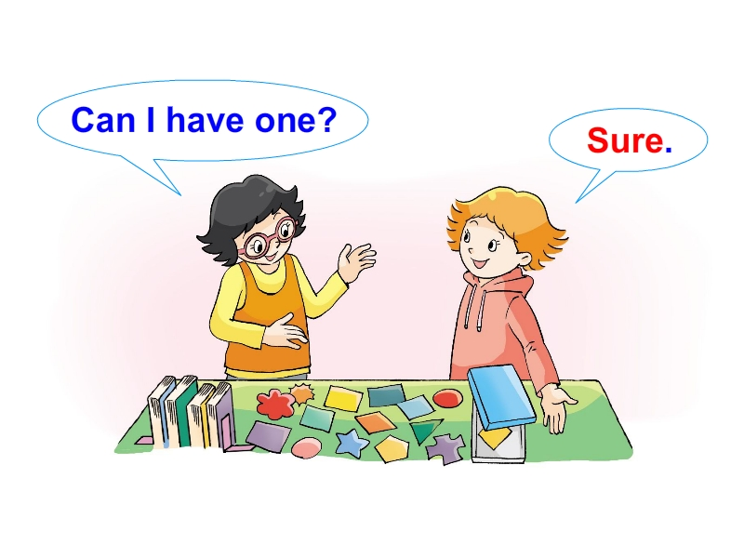  Tip2: 当你请求看别人的物品时，可以用Can I have a look ? 来征求别人的同意  Tip3: “one”在这里用来指代上文提过的物品(sticker)。  - Listen and imitate  T: Now, let’s read after the tape. Pay attention to the tones and intonations.  - Happy reading.  Read in groups of four. You can choose one way you like to read.  A.Read after one;  B.Read by turns;  C.Read together;  D.Read in roles…  8. Show time  T: It’s time for you to perform. Choose one way to read in the front of the classroom. |  | - Ss look and answer.  - Ss watch and answer.  - Ss listen and fill in the table.  - Ask and answer.  - Read and choose.  - Listen and imitate  - Ss choose one way to read.  - Some groups are asked to perform in class. |  | 给学生足够的时间朗读课文，学生可以根据自己的喜好选择朗读的方式，考虑到了每个学生的需求，有助于学生培养良好的语音语调，也有助于学生进一步理解课文中的语句。
   | What | How many
  Mike | toy cars | thirteen
  Helen | stickers | fifteen
Step4  Consolidation | - Choose a situation and make a new dialogue.  场景1：同学互借文具  A: Do you have ….?  B: Yes, I do./ No, I don’t.  A: How many … do you have?  B: I have ...  A: Can I have one?  B: Sure./ Yes./ OK.  A: Thanks.  场景2：同学来你家拜访，你向他/她介绍你所拥有的东西  A: Hello, what do you have?  B: I have…  A: They are nice/lovely…  How many … do you have?  B: I have… Do you have any …s?  A: Yes, I do. / No, I don’t.  …  - Summary  ①从13数到19：  thirteen, fourteen, fifteen, sixteen, seventeen, eighteen, nineteen  ②如何询问别人拥有什么物品？  What do you have?  ③如何询问别人拥有的物品数量？  How many … do you have?  ④想看一看别人的物品应当如何征求同意？  Can I have a look? |  | - Ss make a new dialogue in pairs.  - Ss make a summary. |  | 对整节课进行总结回顾，让学生了解自己在这节课中的所得所获。
Step5  Homework | （必做）A. 听磁带，有感情地模仿熟读课文并尝试背诵。  B. 和朋友一起表演故事。  （选做） 假设朋友来你家做客，你向他/她介绍你的玩具，你们之间会怎么说呢？参照课文，编一个小对话，并尝试把它表演出来吧。
板书设计 | Unit3 How many  13 thirteen  14 fourteen  A: What do you have?  B: I have…  A: How many … do you have?  B: I have …  15 fifteen  16 sixteen  17 seventeen  18 eighteen  19 nineteen
教学反思

